### Project Title:

|  |  |
| --- | --- |
|  |  |
| Billing System |  |
| *by:* ***Himanshu Jadoun*** |  |

### Abstract:

A billing system can be very useful within a business environment. Instead of making bills manually or to sum up the total manually, it is very much time consuming and also may have some human errors like adding up the wrong total or adding wrong items into the bill. When making a hand written bill the owner and customer both have to repeatedly check the total, items added, etc. It also sometimes results into a Bad Impression towards the Restaurant from a Customer. Ideally, user should be able to generate bill without any mistakes and quickly, enabling them to fasten or improve their process. To overcome this problem, we have come up with this project, that is, Restaurant Billing System Using Python.

### INTRODUCTION?

Restaurant Billing System Using Python can be very useful within a business environment. Instead of doing manual work for making up a bill at Restaurant, which gets tiring and time consuming, you can generate a bill including tax and service charges in just few clicks. When making up a bill manually at a Restaurant may contain some human errors like adding wrong items into the bill or summing up their total also may end up wrong, it also sometimes results into a Bad Impression towards the Restaurant from a Customer. Ideally, user should be able to generate bill without any mistakes and quickly, enabling them to fasten or improve their process. To overcome this problem, we have come up with this project, that is, Restaurant Billing System Using Python. The Restaurant Billing System Using Python is very useful to small business or restaurant or cafe or food truck owners. This helps the owner to fasten the process which is bug free and easy to use. It also has a calculator to ease the use of the user. This project firstly has the menu and then adds up the selected items by customer and sums up the total of all items adds tax and service charges and displays total. To perform any other operation like division, multiplication, etc calculator is also.

### MOTIVATION AND TECHNICAL RELAVANCE:

The Restaurant industry is enlarging rapidly and restaurant owners are keen to improve every section of their business. Though much attention is paid to digitalizing the restaurant management and the menu, but not many business owners realize the importance of applying digital billing software in the restaurant. The customers' experience at your restaurant includes the billing and payment experiences too. Billing software provides some exclusive features that ease up the restaurant services. It upgrades the billing process and uplift the customers' experience. It enables customers to pay bills more easily. The software can generate detailed bills that eliminate the need to calculate bills separately when the guests wish to know total GST amount. Apart from billing, the software enables you to organize a number of processes at the restaurant. It makes your system more effective and helps you provide faster and easy services to the customers. So many times, customers leave unhappy due to improper billing. When the crowd is vast in the restaurant, it might take you some time to generate manual bills that may leave your customers unsatisfied. This is where the automated billing system can be used. It generates digital bills automatically and allows customers to make quick payments.

***Salient features of billing system:***

* Paperwork reduction.
* Calculate Products Price.
* Calculate Tax on Behalf of Product Category.
* Compliance with GST.
* Instant invoices.
* All Validations no duplicated record insert.
* Prevent errors in the compilation of bills and invoices.
* Maintain a record of all bills and invoices.
* Search Bill Records.

**PROPOSED SYSTEM:**

Since many restaurant or café owners make bills for their customers manually with a pen paper. This sometimes results into an error of total or wrong items added or some items missing in bill or extra items added. This may end up by building up a bad impression of customer towards the Café or restaurant. So, to overcome this problem we’ve come up with this helpful project named Restaurant Billing System Using Python.

We all love going to cafes or restaurants but when it takes time for them to make a bill or if they Make wrong bill then it’s time consuming. So, to avoid all such chaos our project will help in All possible terms.

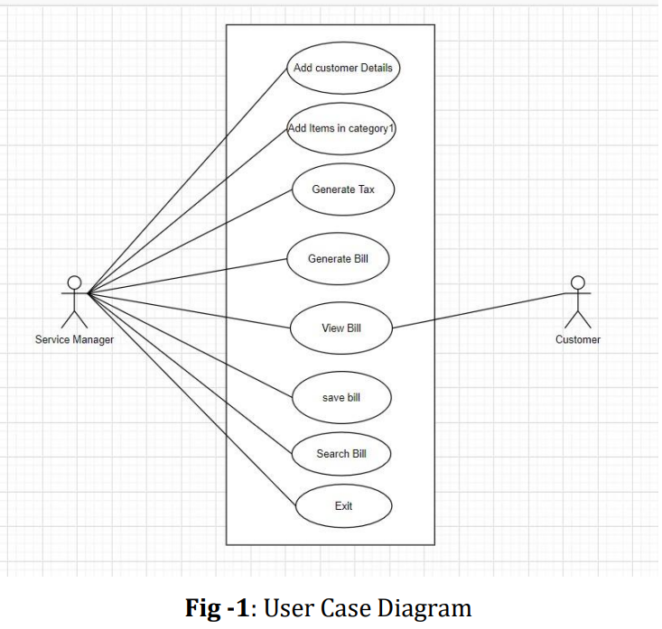

SYSTEM REQUIREMENTS AND SPECIFICATIONS:

The software and the hardware to be used for developing the project and implementing the project are:

**A. Software Requirements:**

1. Python 3,9
2. Notepad
3. Any OS

**B. Hardware Requirements:**

1. 2 GB RAM or above
2. Intel i3 Processor or above

3. 32 Bit System or above

### SYSTEM IMPLEMENTATION:

The restaurant Billing System is developed using Python. While using this billing management system, you can easily calculate the total bill of the customer. Moreover, the total bill is calculated including service charges and state tax. All you need to do is just fill up the blank boxes with item quantities and click on the total button. The program will display your total bill. This system can be used in restaurants, cafés, and food trucks for calculating bills in a short period of time and it’s not time-consuming. It’s easy to operate and understand by users. There is no error or warning contained in the project. The design is so simple that users won’t find it difficult to use and navigate.

To ease the use of the user we even have a calculator added to our system which performs all basic operations like Addition, Subtraction, Division, and Multiplication. We’ll display Menu, Order no., Total and Reset. We assure you that the project is bug-free and easy to use.

Since the program is for restaurants or providing services. It will add services charges and state taxes respectively.

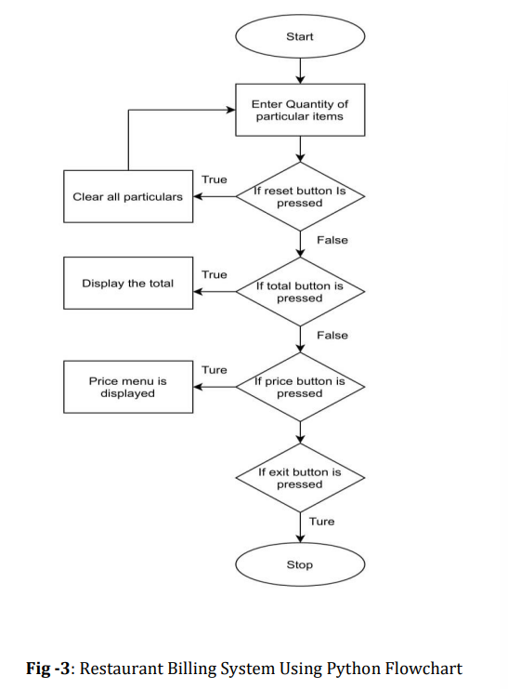

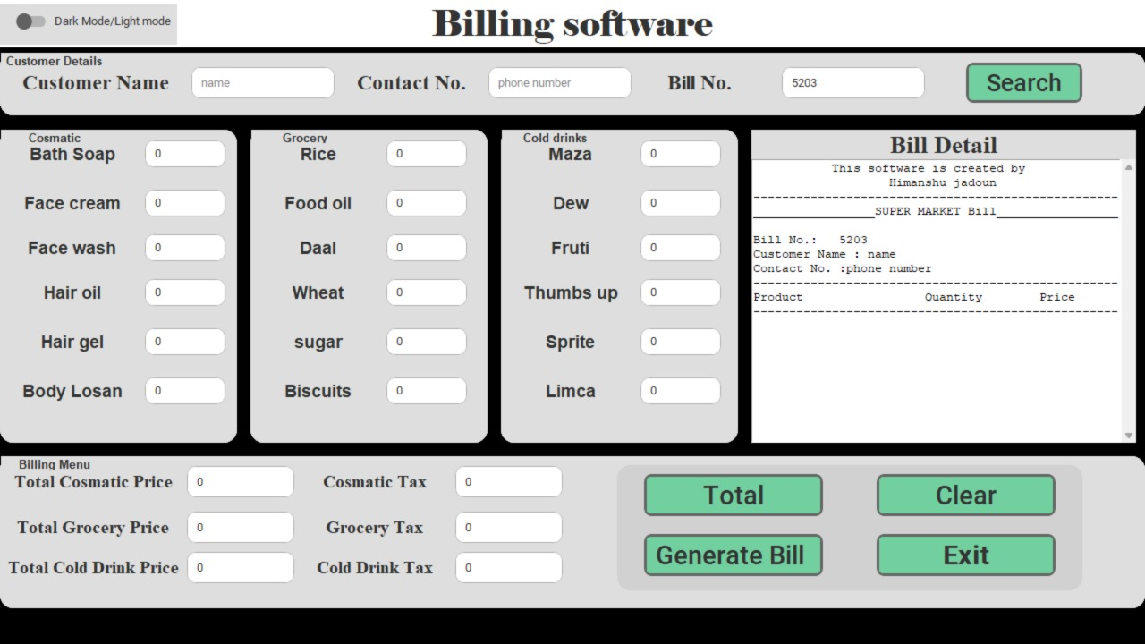

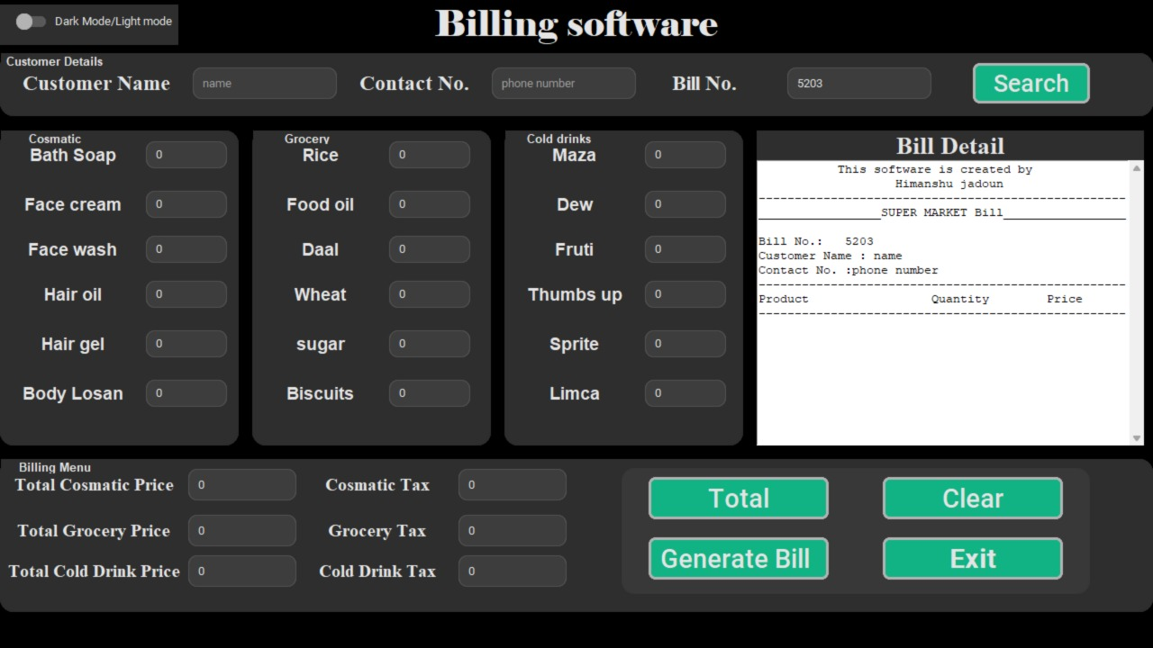

**Fig -4:** Restaurant Billing System Using Python Home screen (both in light mode and dark mode.)

### 

### ACKNOWLEDGEMENTS:

We as part of our final year project at VESP developed and tested the software under the guidance of Professor Dashrath Kale. After Analyses of the data, we wrote the manuscript. He has read and approved the final manuscript.

### CONCLUSION:

The urge for the digital restaurant management systems is increasing day by date. Restaurant Billing System Using Python is a perfect solution for this. Through this the ease of access and flexibility of the day to day works in the restaurant is made simpler. The features such as bill number, CGST and SGST make this software user friendly. Both the management side and worker site can manage the data easily using such a system. It is very good and reliable system which can be in corporate to the chain of hotels so can easily maintained and addressed.

**References/Bibliography:**

**[1]** Noor Azah Samsudin, Shamsul Kamal Ahmad Khalid, Mohd Fikry Akmal Mohd Kohar, Zulkifli Senin, Mohd Nor Ihkasan; “A Customizable Wireless Food Ordering System with Real-Time Customer Feedback.”; 2011 IEEE Symposium on Wireless Technology and Applications (ISWTA), September 25-28, 2011, Langkawi, Malaysia.

**[2]** Sakari Pieskä, Markus Liuska, Juhana Jauhiainen, and Antti Auno of Centria University of Applied Sciences Ylivieska; “Intelligent Restaurant System Smart Menu That Digital Technology”; coginfocom 2013 4th IEEE International Conference on Cognitive Info-communications December 2–5, 2013, Budapest, Hungary.

**[3]** Ching-chang, Chechen Kung, Tan-Hsu Tan,” Development and Implementation of an E-Restaurant for Customer-Centric Service Using Wlan and Rfid Technology”, Proceedings of the Seventh International Conference On Machine Learning And Cybernetics, Kunming, 12-15 July 2008.